Report Prepared by: Bello Bolaji Alabi

Date: 7th of December, 2024

Introduction

**Purpose of the Report**

This report aims to provide a detailed analysis of global internet user trends and cellular/broadband subscription patterns from 1980 to 2020. It highlights key insights, presents actionable recommendations, and explores the implications of these findings for decision-making while identifying potential areas for further research.

**Methodology**

The dataset was sourced from Kaggle and cleaned using Excel. Power BI was utilized for data visualization to ensure clear and actionable insights.

**Global Internet User Trends**

**Insight**:

* Internet usage has experienced steady growth since the early 2000s, reaching a total of 97 billion users globally by 2020.Top of Form

Bottom of Form

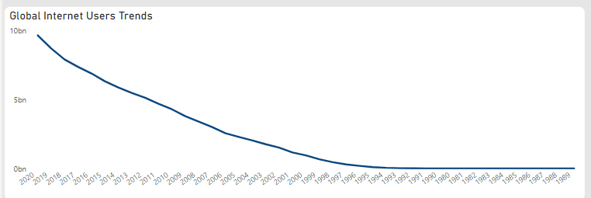

**Decision Implications**

* **Infrastructure Scalability**: Governments and technology companies must prioritize scaling internet infrastructure to accommodate rapid user growth.
* **Business Opportunities**: Organizations should target emerging internet markets for launching products and delivering digital services.

**Areas for Further Investigation**

* **Growth Drivers**: Explore factors driving rapid internet growth in the early 2000s, such as advancements in technology, increased affordability, and supportive government policies.
* **Regional and Demographic Trends**: Conduct detailed analyses of internet adoption patterns across specific regions and demographics.

**Broadband Subscriptions in Top 6 Countries**

**Insight**:

* Monaco leads in broadband subscriptions with 765, followed by South Korea (674), Liechtenstein (670), Denmark (670), and Switzerland (664).
* This reflects superior fixed-line internet infrastructure in these nations.

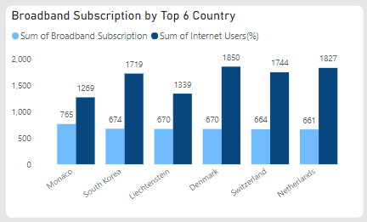

**Decision Implications**

* **Model for Broadband Development**: Countries like Monaco and South Korea, with advanced broadband infrastructure, can serve as benchmarks for nations seeking to improve fixed-line internet services.
* **Focus on Accessibility**: Internet service providers (ISPs) in developing regions should prioritize affordability and infrastructure expansion to close the broadband adoption gap.

**Areas for Further Investigation**

* **Broadband's Impact**: Examine how broadband access influences education, healthcare, and economic productivity in leading countries.
* **Infrastructure Challenges**: Identify and analyze barriers to broadband adoption in regions with low penetration rates.

**Cellular Subscriptions in Top 6 Countries**

**Insights**:

* Countries with the highest cellular subscriptions include:
  + **Macao**: 4.7K subscriptions
  + **Hong Kong**: 4.2K subscriptions
  + **United Arab Emirates, Italy, Luxembourg, Finland, and Cayman Islands**: Ranging from 2.8K to 3K subscriptions
* These nations exhibit high mobile penetration rates, often linked to urbanization and rapid technological adoption.

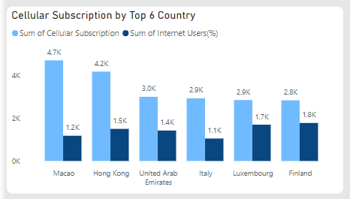

**Decision Implications**

* **Mobile-First Strategies**: Telecom providers should focus on regions with high mobile penetration by introducing 5G networks and mobile-centric services.
* **Leveraging Mobile Penetration**: Governments can harness widespread mobile access to advance e-governance initiatives and expand digital public services.

**Areas for Further Investigation**

* **Correlation Analysis**: Explore the relationship between cellular penetration, internet access, and economic development.
* **Service Quality Challenges**: Investigate the difficulties of maintaining high service quality amid growing subscription numbers.

**Top 10 Countries with Internet Access Percentage**

Countries with the highest percentage of users having access to the internet:

1. **Iceland**: 2.00K
2. **Norway**: 1.95K
3. **Sweden**: 1.90K
4. **Denmark**: 1.85K
5. **Netherlands**: 1.83K
6. **Finland**: 1.76K
7. **Canada**: 1.75K
8. **Switzerland**: 1.74K
9. **South Korea**: 1.72K
10. **Luxembourg**: 1.70K

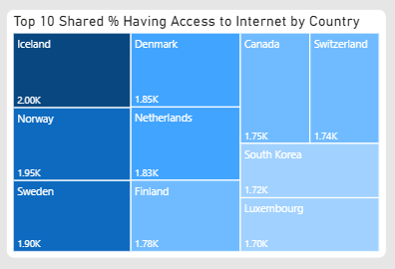

**Decision Implications**

* **Advanced Digital Solutions**: Regions with high internet access should invest in cutting-edge technologies like smart cities, IoT, and AI-powered platforms.
* **Infrastructure Prioritization**: Policymakers in areas with limited access should focus on improving affordability and expanding internet infrastructure.

**Areas for Further Investigation**

* **Policy Comparisons**: Examine how policy frameworks differ between countries with high and low internet access rates.
* **Impact of Digital Literacy**: Investigate the role of digital literacy programs in improving internet access in developing regions.

**Global Internet Users by Country:**

**Insights**

* **China** leads with 9 billion internet users.
* **North America** follows with 7 billion users.
* **United States** and **India** account for 5 billion and 3 billion users, respectively.
* Other contributors include Brazil, Japan, and smaller nations.

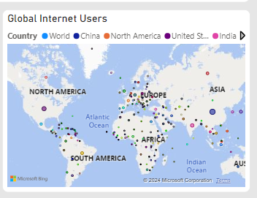

**Decision Implications**

* **Focus on Key Markets**: Businesses should prioritize market expansion in China and North America due to their substantial user bases.
* **Digital Access Initiatives**: Policymakers in countries with smaller user bases should emphasize programs to enhance digital accessibility.

**Areas for Further Investigation**

* **Factors Driving High User Counts**: Explore the role of government policies, economic factors, and population size in shaping internet adoption in China and North America.
* **Addressing the Digital Divide**: Analyze disparities within countries to identify and support underserved populations.

**Strategic Recommendations**

1. **Expand into Emerging Markets**:
   * Regions with low internet penetration, such as parts of Africa and South Asia, offer untapped growth potential. Collaboration between telecom providers and governments is crucial to build infrastructure and promote affordable internet access.
2. **Adopt Mobile-First Strategies**:
   * High mobile penetration in regions like Macao, Hong Kong, and the UAE presents opportunities for mobile-driven services, including mobile banking, e-commerce, and streaming platforms.
3. **Improve Broadband Infrastructure**:
   * Governments in lagging regions should prioritize broadband development, taking cues from successful models like Monaco and South Korea.
4. **Promote Digital Inclusion**:
   * Governments and NGOs must implement digital literacy programs to close the digital divide and ensure equitable internet access for all.
5. **Leverage User Trends for Growth**:
   * Businesses should monitor rapidly growing markets like India and Brazil and introduce localized solutions to tap into these emerging opportunities.

**Conclusion**

The analysis highlights the impressive global growth in internet adoption, disparities in digital access, and the potential for expansion in emerging regions. By leveraging these insights, policymakers, businesses, and ISPs can drive inclusive digital transformation and sustainable growth. Ongoing studies targeting specific regions and demographics will further refine strategies, ensuring global progress in internet accessibility.